Collective Worship Summer 2024
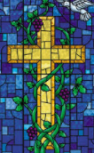

Date | Focus
08.4.24 | God helps David be wise and merciful.  David and Saul in the cave. 1 Samuel 24
15.4.24 | Wisdom is not always dependent on age.  The boy Jesus in the temple. Luke 2:41-52
22.4.24 | Jesus says that being wise is listening to what he says and putting it into action The story of the wise and foolish builder. Matthew 7 v 24-27
29.4.24 | Wisdom comes in all sorts of different styles  St Hild & Caedmon.
06.5.24 | May Day
13.5.24 | Pentacost ( Sunday 19th May)
20.5.24 | Explanation of ‘for the kingdom, the power and the glory are yours now and forever’.

Collective Worship Summer 2024
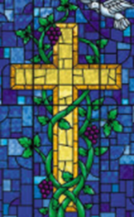

Date | Theme
3.6.24 | God promises a peaceful future.  Isaiah 11 v 1-9 also Isaiah 2 v 4
10.6.24 | Jesus’ kingdom belongs to children.  Jesus puts a child in the midst. Matthew 19:13-14
17.6.24 | We hear about the peace-making community at Corrymeela.  Summer Days
24.6.24 | School Value - Determination
1.7.24 | School Value -Trust
8.7.24 | School Value - Friendship
15.7.24 | School Value - Respect  Reflection and celebration

